Ministry of Education and Science of Ukraine
National Technical University of Ukraine
“Igor Sikorsky Kyiv Polytechnic Institute”
Educational and Scientific Institute of Nuclear and Thermal Energy
Department of digital technologies in energy

Calculation and graphic work in the discipline
“Methods of synthesis of virtual reality”

Prepared by:
5th-year student
Group TR-41mp
Kondrashin O. M.

Kyiv - 2025
1 TASK DESCRIPTION

- Reuse the code from practical assignment #2.
- Implement sound source rotation around the geometrical center of the surface patch by means of a tangible interface (the surface stays still this time, and the sound source moves). Reproduce your favorite song in mp3/ogg format, having the spatial position of the sound source controlled by the user.
- Visualize the position of the sound source with a sphere.
- Add a sound filter (use BiquadFilterNode interface) per variant. Add a checkbox element that enables or disables the filter. Set filter parameters according to your taste.

2 THEORY DESCRIPTION

2.1 WebGL

WebGL (Web Graphics Library) is a JavaScript API designed for rendering interactive 2D and 3D graphics directly within a web browser, eliminating the need for additional plug-ins or software installations. It leverages the capabilities of OpenGL ES 2.0, making it highly versatile and compatible with a wide range of devices and platforms, including desktops, smartphones, and tablets. WebGL integrates seamlessly with other web technologies such as HTML5 and the DOM (Document Object Model) by operating directly within the browser environment. This integration allows developers to create dynamic and visually rich web applications, from simple animations to complex 3D visualizations and games. The cross-platform compatibility and native browser support ensure accessibility and performance consistency, making WebGL a powerful tool for modern web development.

2.2 Tangible Interfaces

Tangible interfaces are interactive systems that bridge the gap between the physical and digital worlds by using real-world objects as input devices. These interfaces enable users to manipulate digital information through physical actions, such as moving, rotating, or touching objects embedded with sensors or tracking technologies. Tangible user interfaces combine aspects of industrial design, human-computer interaction, and embedded computing to create intuitive and engaging experiences. They often leverage motion sensing to detect and interpret user actions. By grounding digital interactions in the physical environment, tangible interfaces can enhance learning, collaboration, and creativity, especially in fields like education, design, and data visualization. Their physical nature supports spatial reasoning and muscle memory, making digital tasks more natural and accessible, particularly for users who benefit from tactile feedback and embodied cognition.

2.3 WebSockets

WebSockets are a communication protocol that provides full-duplex, bidirectional communication channels over a single, long-lived TCP connection. Unlike traditional HTTP requests, which follow a request-response model, WebSockets enable real-time data exchange between a client and a server without the overhead of repeatedly opening new connections. A WebSocket connection begins with a standard HTTP handshake, after which the protocol switches to WebSocket, allowing both the client and server to send data independently at any time. WebSockets are supported by most modern browsers and are typically implemented using JavaScript on the client side. This low-latency, persistent connection model significantly improves the responsiveness and interactivity of web applications, making WebSockets a foundational technology for real-time web development.

2.4 Web Audio HTML5 API

The Web Audio API is a high-level JavaScript API designed for creating, processing, and controlling audio directly in the browser. It provides a powerful and flexible system for working with audio, enabling developers to build complex audio applications such as music synthesizers, games with dynamic sound effects, and interactive sound visualizations. The API is based on the concept of an audio context, which acts as the central hub for managing audio operations. Within this context, various audio nodes can be created and connected in a directed graph to define audio processing paths. These nodes include sources, effects, filters, and outputs. Audio is processed in real-time, with support for 3D spatialization, audio analysis, and precise scheduling of sound playback. As part of HTML5, the Web Audio API is widely supported in modern browsers and plays a key role in enabling rich, interactive audio experiences on the web without the need for external plugins.
3 IMPLEMENTATION DETAILS

3.1 Web page description, index.html

In this HTML file a basic web page for displaying and interacting with a 3D graphics application is defined. The page uses HTML5, CSS, and JavaScript to create an interactive 3D WebGL canvas where users can move a 3D object using tangible interface gestures. JavaScript scripts are included to support core functionalities: m4.js offers matrix operations, and other scripts such as main.js, Model.js, and Texture.js handle rendering logic, 3D model data, and texture mapping. The onload="init()" attribute ensures that the 3D application initializes once the page is fully loaded, making this a functional framework for exploring WebGL-based geometric visualization.

3.2 Main application logic, main.js

First, this script initializes a media stream from the user’s web camera. After that, the file sets up the WebGL context and shader programs using the initGL function and the ShaderProgram constructor. Loads shaders, assigns attribute locations, and initializes transformation matrices for rendering. The script also maintains a connection with a phone through a WebSocket, and monitors the data it receives using the onmessage event handler. Based on the received data, the script updates the position of a visualised sound source dynamically. The draw function applies transformations and renders the surface in the middle, the spherical surface, which represents the sound source, and a webcam background. Sound location is handled by FUNCTIONNAME function, which adjusts sound source coordinates corresponding to its visual appearance on the canvas.

3.3 Surface model class Model.js

This JavaScript file implements a 3D model data calculation and storage. A deg2rad function to convert degrees to radians for geometric calculations. Vertex and Triangle classes represent the basic building blocks of a 3D model, including position and connectivity. The Model class manages buffers for vertices and indices. The class includes the following methods:
- BufferData uploads vertex and index data to GPU buffers.
- Draw renders the model using WebGL's gl.drawElements.
- DrawWireframe renders a wireframe of the surface on top of the model.
The CreateSurfaceData function generates vertices and triangles for the surface in the middle of the canvas, which represents the user.
The CreateSurfaceDataBall function generates vertices and triangles for the spherical surface, which represents the sound source.
4 USER’S INSTRUCTION

4.1 Setup

Open the project in a modern web browser that supports WebGL using the Live server Visual Studio Code extension, and allow access to the webcamera (Fig. 4.1).

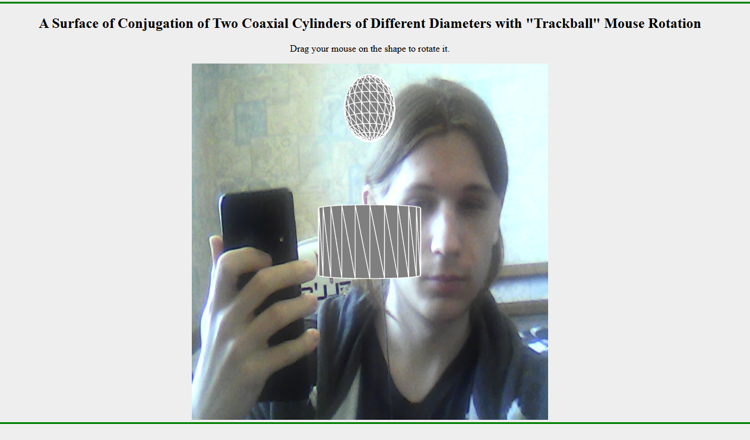

Figure 4.1. Homepage.

4.2 Enable sensor server

Use the start button in the sensor server app to start streaming phone sensor data into the web client (Fig. 4.2).
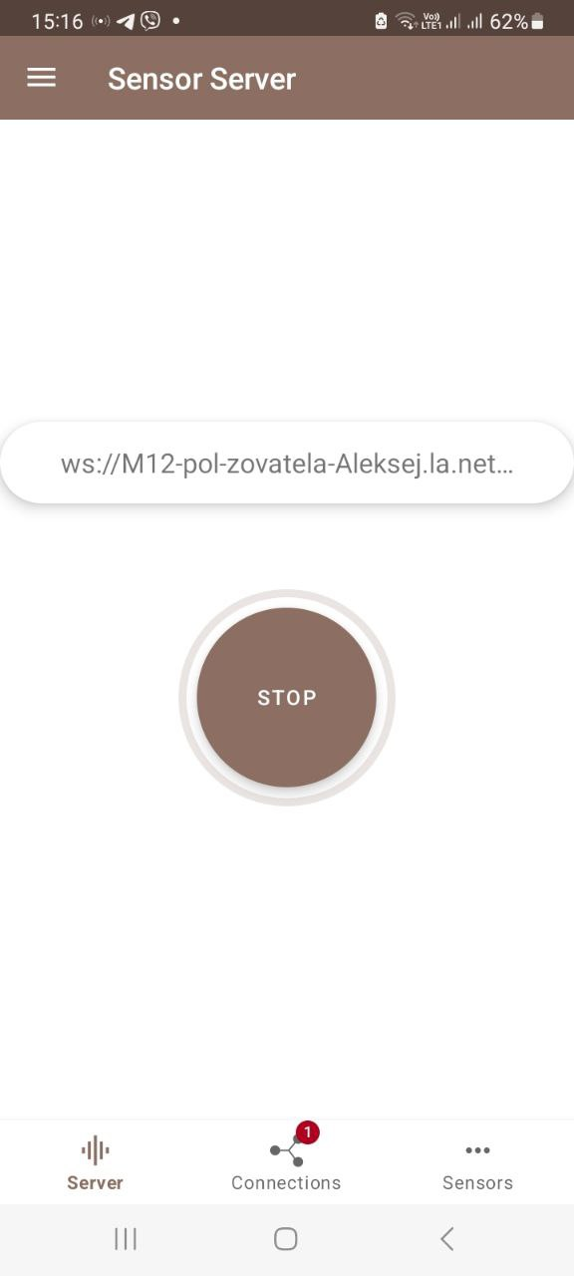

Figure 4.2. Enabled sensor server.

4.3 Adjusting sound source position.

Use phone orientation to position the sound source (Fig. 4.3).

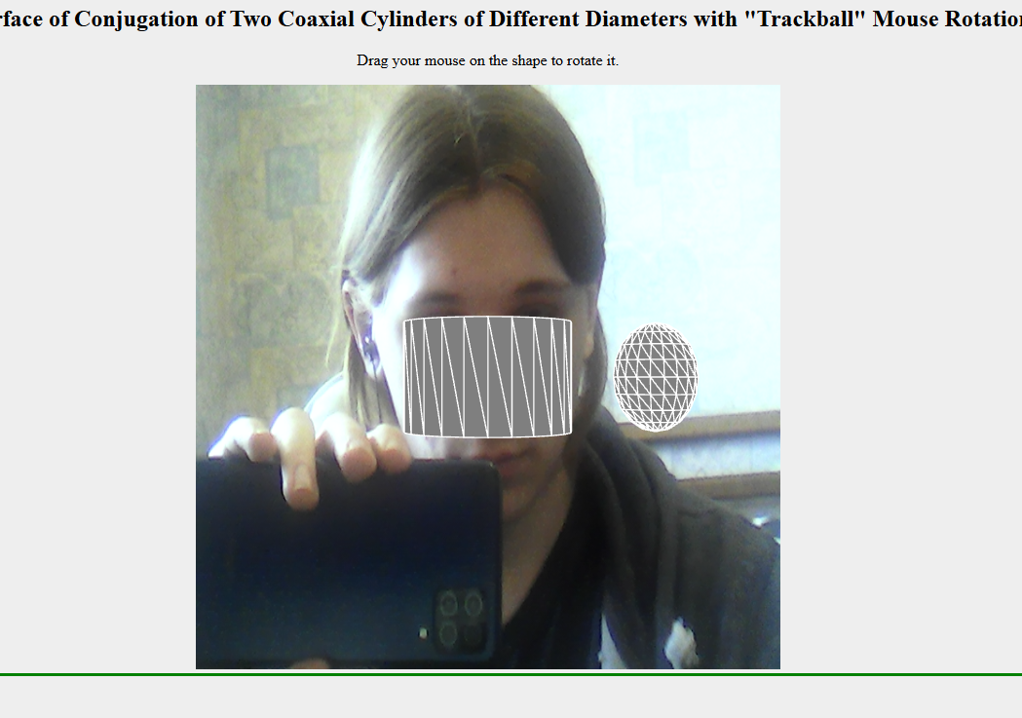

Figure 4.3. Position adjustment demonstration.

5 SOURCE CODE SAMPLE

'use strict';

let gl; // The webgl context.
let surface; // A surface model
let surfaceWebCam; // A substrate for webcam image
let shProgram; // A shader program
//let bgProgram;
let spaceball; // A SimpleRotator object that lets the user rotate the view by mouse.
let stereoCam; // Object holding stereo camera and its parameters

let iTextureWebCam = -1;
let step1 = 15;
let step2 = 1;
let video;
let webcamElement;
let videoTexture
var sound = {};
var ctx = new AudioContext();
const renderingParams = {
eyeSeparation: 0.1,
fov: 30 *Math.PI / 180,
nearClip: 8.0,
convergence: 8.7,
};

let phoneX = 0;
let phoneY = 0;

// Websocket stuff

const WS_URL = "ws://192.168.0.177:8080/sensor/connect?type=android.sensor.device_orientation";

let socket;
let reconnectInterval = 3000;

function connectWebSocket() {
console.log("Attempting to connect...");

socket = new WebSocket(WS_URL);

socket.onopen = () => {
console.log("WebSocket connection established.");
};

socket.onmessage = (event) => {
try {
const data = JSON.parse(event.data);
console.log(data)
let orientationState = parseFloat(data.values?.[0]);

if (!isNaN(orientationState)) {
if(orientationState == -1){
phoneX = 0;
phoneY = 0
}else if(orientationState == 0){
phoneX = 0
phoneY = 2
}else if(orientationState == 1){
phoneX = -2
phoneY = 0
}else if(orientationState == 2){
phoneX = 0
phoneY = -2
}else if(orientationState == 3){
phoneX = 2
phoneY = 0
}
sound.panner.positionX.setValueAtTime(phoneX, ctx.currentTime);
sound.panner.positionY.setValueAtTime(phoneY, ctx.currentTime);
sound.panner.positionZ.setValueAtTime(0, ctx.currentTime);
console.log("Data: ", data);
} else {
console.warn("Invalid angle in message:", data);
}
} catch (err) {
console.error("Error parsing message:", err);
}
};

socket.onerror = (error) => {
console.error("WebSocket error:", error);
};

socket.onclose = (event) => {
console.warn("WebSocket closed. Reconnecting in 3 seconds...", event.reason);
setTimeout(connectWebSocket, reconnectInterval);
};
}

// Start connection
connectWebSocket();

// Constructor
function ShaderProgram(name, program, bgProgram, videoProg) {

this.name = name;
this.prog = program;
this.bgProgram = bgProgram
this.videoProg = videoProg
// Location of the attribute variable in the shader program.
this.iAttribVertex1 = -1;
// Location of the uniform specifying a color for the primitive.
this.iColor1 = -1;
// Location of the uniform matrix representing the combined transformation.
this.iModelViewProjectionMatrix1 = -1;

// Location of the attribute variable in the shader program.
this.iAttribVertex2 = -1;
// Location of the uniform specifying a color for the primitive.
this.iColor2 = -1;
// Location of the uniform matrix representing the combined transformation.
this.iModelViewProjectionMatrix2 = -1;

this.Use = function(progType) {
if(progType == 'main'){
gl.useProgram(this.prog);
}
if(progType == 'background'){
gl.useProgram(this.bgProgram);
}
if(progType == 'video'){
gl.useProgram(this.videoProg);
}
}
}

async function initWebcam() {
webcamElement = document.getElementById("webcam");
try {
const stream = await navigator.mediaDevices.getUserMedia({ video: true });
webcamElement.srcObject = stream;

// Create and set up video texture
videoTexture = gl.createTexture();
gl.bindTexture(gl.TEXTURE_2D, videoTexture);
gl.texParameteri(gl.TEXTURE_2D, gl.TEXTURE_MIN_FILTER, gl.LINEAR);
gl.texParameteri(gl.TEXTURE_2D, gl.TEXTURE_WRAP_S, gl.CLAMP_TO_EDGE);
gl.texParameteri(gl.TEXTURE_2D, gl.TEXTURE_WRAP_T, gl.CLAMP_TO_EDGE);
initBackgroundShaders()
} catch (error) {
console.error("Error accessing webcam:", error);
}
}

function drawVideoBackground() {
if (!shProgram || !shProgram.videoProg) {
initBackgroundShaders();
}

shProgram.Use('video')

// Set up a simple quad for the background
const vertices = new Float32Array([1, 1, -1, 1, 1, -1, -1, -1]);

const texCoords = new Float32Array([0, 0, 1, 0, 0, 1, 1, 1]);

// Create and bind buffers
const vertexBuffer = gl.createBuffer();
gl.bindBuffer(gl.ARRAY_BUFFER, vertexBuffer);
gl.bufferData(gl.ARRAY_BUFFER, vertices, gl.STATIC_DRAW);

const texCoordBuffer = gl.createBuffer();
gl.bindBuffer(gl.ARRAY_BUFFER, texCoordBuffer);
gl.bufferData(gl.ARRAY_BUFFER, texCoords, gl.STATIC_DRAW);

//Set up attributes
const positionLoc = gl.getAttribLocation(
shProgram.videoProg,
"position",
);
const texCoordLoc = gl.getAttribLocation(
shProgram.videoProg,
"texCoord",
);

gl.bindBuffer(gl.ARRAY_BUFFER, vertexBuffer);
gl.enableVertexAttribArray(positionLoc);
gl.vertexAttribPointer(positionLoc, 2, gl.FLOAT, false, 0, 0);

gl.bindBuffer(gl.ARRAY_BUFFER, texCoordBuffer);
gl.enableVertexAttribArray(texCoordLoc);
gl.vertexAttribPointer(texCoordLoc, 2, gl.FLOAT, false, 0, 0);

// Update texture
gl.bindTexture(gl.TEXTURE_2D, videoTexture);
gl.texImage2D(
gl.TEXTURE_2D,
0,
gl.RGBA,
gl.RGBA,
gl.UNSIGNED_BYTE,
webcamElement,
);

// Draw
gl.drawArrays(gl.TRIANGLE_STRIP, 0, 4);

// Switch back to main program
shProgram.Use('main')
}

function initBackgroundShaders() {
const backgroundVertexShader = `
attribute vec3 vertex2;
uniform mat4 ModelViewMatrix2;
uniform mat4 ProjectionMatrix2;

void main() {
gl_Position = ProjectionMatrix2 * ModelViewMatrix2 * vec4(vertex2, 1.0);
}
`;

const backgroundFragmentShader = `
#ifdef GL_FRAGMENT_PRECISION_HIGH
precision highp float;
#else
precision mediump float;
#endif

uniform vec4 color2;
void main() {
gl_FragColor = color2;
}
`;

const videoVertexShader = `
attribute vec2 position;
attribute vec2 texCoord;
varying vec2 vTexCoord;
void main() {
gl_Position = vec4(position, 0.0, 1.0);
vTexCoord = texCoord;
}
`;

const videoFragmentShader = `
precision mediump float;
uniform sampler2D uTexture;
varying vec2 vTexCoord;
void main() {
gl_FragColor = texture2D(uTexture, vTexCoord);
}
`;

let prog = createProgram( gl, vertexShaderSource, fragmentShaderSource );
let progbg = createProgram( gl, backgroundVertexShader, backgroundFragmentShader );
let progvid = createProgram( gl, videoVertexShader, videoFragmentShader );
shProgram = new ShaderProgram('Basic', prog, progbg, progvid);
console.log(shProgram)
//shProgram.Use('background')
}

/* Draws a colored cube, along with a set of coordinate axes.
* (Note that the use of the above drawPrimitive function is not an efficient
* way to draw with WebGL. Here, the geometry is so simple that it doesn't matter.)
*/

function drawCylinderBackground() {

shProgram.Use('background')

// TODO: Place your code here to draw webCam surface
// Draw background video if available
let data = {};

CreateSurfaceData(data, step1, step2)

surface = new Model('Surface', 2);
surface.BufferData(data.verticesF32, data.indicesU16);
/* Get the view matrix from the SimpleRotator object.*/
let modelView = [1, 0, 0, 0, 0, 1, 0, 0, 0, 0, 1, 0, 0, 0, 0, 1]
let rotateToPointZero = m4.axisRotation([0.707,0.707,0], 0);
let rotateByPhone = m4.axisRotation([0,0,1], 0)
let translateToPointZero = m4.translation(0,-0.5,-10);

const colorPolygon = new Float32Array([0.5,0.5,0.5,1]);
const colorEdge = new Float32Array([1,1,1,1]);

// The FIRST PASS (for the left eye)

let matrLeftFrustum = stereoCam.calcLeftFrustum();
gl.uniformMatrix4fv(shProgram.iProjectionMatrix2, false, matrLeftFrustum);

let translateLeftEye = m4.translation(stereoCam.eyeSeparation/2, 0, 0);

let rotatedModelView = m4.multiply(rotateByPhone, modelView)
let matAccum0 = m4.multiply(rotateToPointZero, rotatedModelView );
let matAccum1 = m4.multiply(translateLeftEye, matAccum0 );
let matAccum2 = m4.multiply(translateToPointZero, matAccum1 );

gl.uniformMatrix4fv(shProgram.iModelViewMatrix2, false, matAccum2 );

gl.enable(gl.POLYGON_OFFSET_FILL);
gl.polygonOffset(1,0);

gl.colorMask(true, true, true, true);
gl.uniform4fv(shProgram.iColor2, colorPolygon );
surface.Draw();
gl.uniform4fv(shProgram.iColor2, colorEdge );
surface.DrawWireframe();

// RESET specific params to their default state

gl.disable(gl.POLYGON_OFFSET_FILL);
gl.colorMask(true, true, true, true);
//console.log(shProgram)
// Switch back to main program
shProgram.Use('main')
}

function draw() {
gl.clearColor(0,0,0,1);
gl.clear(gl.COLOR_BUFFER_BIT | gl.DEPTH_BUFFER_BIT);
// PATH ZERO: DRAW ZERO PARALLAX WEBCAM

let matrOrth = m4.orthographic(0,1,0,1, 8,20);

// TODO: Place your code here to draw webCam surface
// Draw background video if available
drawVideoBackground();
drawCylinderBackground();
let data = {};

CreateSurfaceDataBall(data)

surface = new Model('Surface', 1);
surface.BufferData(data.verticesF32, data.indicesU16);
/* Get the view matrix from the SimpleRotator object.*/
let modelView = spaceball.getViewMatrix();

let rotateToPointZero = m4.axisRotation([0.707,0.707,0], 0);
let rotateByPhone = m4.axisRotation([0,0,1], 0)
let translateToPointZero = m4.translation(phoneX,phoneY,-10);

const colorPolygon = new Float32Array([0.5,0.5,0.5,1]);
const colorEdge = new Float32Array([1,1,1,1]);

// The FIRST PASS (for the left eye)

let matrLeftFrustum = stereoCam.calcLeftFrustum();
gl.uniformMatrix4fv(shProgram.iProjectionMatrix1, false, matrLeftFrustum);

let translateLeftEye = m4.translation(stereoCam.eyeSeparation/2, 0, 0);

let rotatedModelView = m4.multiply(rotateByPhone, modelView)
let matAccum0 = m4.multiply(rotateToPointZero, rotatedModelView );
let matAccum1 = m4.multiply(translateLeftEye, matAccum0 );
let matAccum2 = m4.multiply(translateToPointZero, matAccum1 );

gl.uniformMatrix4fv(shProgram.iModelViewMatrix1, false, matAccum2 );

gl.enable(gl.POLYGON_OFFSET_FILL);
gl.polygonOffset(1,0);

gl.colorMask(true, true, true, true);
gl.uniform4fv(shProgram.iColor1, colorPolygon );
surface.Draw();
gl.uniform4fv(shProgram.iColor1, colorEdge );
surface.DrawWireframe();

// RESET specific params to their default state

gl.disable(gl.POLYGON_OFFSET_FILL);
gl.colorMask(true, true, true, true);
//console.log(shProgram)
}

/* Initialize the WebGL context. Called from init() */
function initGL() {
shProgram.Use('background');

shProgram.iAttribVertex2 = gl.getAttribLocation(shProgram.bgProgram, "vertex2");
shProgram.iModelViewMatrix2 = gl.getUniformLocation(shProgram.bgProgram, "ModelViewMatrix2");
shProgram.iProjectionMatrix2 = gl.getUniformLocation(shProgram.bgProgram, "ProjectionMatrix2");
shProgram.iColor2 = gl.getUniformLocation(shProgram.bgProgram, "color2");

shProgram.Use('main');

shProgram.iAttribVertex1 = gl.getAttribLocation(shProgram.prog, "vertex");
shProgram.iModelViewMatrix1 = gl.getUniformLocation(shProgram.prog, "ModelViewMatrix");
shProgram.iProjectionMatrix1 = gl.getUniformLocation(shProgram.prog, "ProjectionMatrix");
shProgram.iColor1 = gl.getUniformLocation(shProgram.prog, "color");

//surfaceWebCam = new Model('SurfaceWebCam');
// TODO: Place your code here to load two triangle geomtery

stereoCam = new StereoCamera(
renderingParams.eyeSeparation, // decimeters
renderingParams.convergence, // decimeters
1.3, // aspect ratio of canvas
renderingParams.fov, // radians
renderingParams.nearClip, // decimeters
20.0 // decimeters
);

gl.enable(gl.DEPTH_TEST);
}

function createProgram(gl, vShader, fShader) {
let vsh = gl.createShader( gl.VERTEX_SHADER );
gl.shaderSource(vsh,vShader);
gl.compileShader(vsh);
if ( ! gl.getShaderParameter(vsh, gl.COMPILE_STATUS) ) {
throw new Error("Error in vertex shader: " + gl.getShaderInfoLog(vsh));
}
let fsh = gl.createShader( gl.FRAGMENT_SHADER );
gl.shaderSource(fsh, fShader);
gl.compileShader(fsh);
if ( ! gl.getShaderParameter(fsh, gl.COMPILE_STATUS) ) {
throw new Error("Error in fragment shader: " + gl.getShaderInfoLog(fsh));
}
let prog = gl.createProgram();
gl.attachShader(prog,vsh);
gl.attachShader(prog, fsh);
gl.linkProgram(prog);
if ( ! gl.getProgramParameter( prog, gl.LINK_STATUS) ) {
throw new Error("Link error in program: " + gl.getProgramInfoLog(prog));
}
return prog;
}

/**
* initialization function that will be called when the page has loaded
*/
async function init() {
let canvas;
try {
canvas = document.getElementById("webglcanvas");
gl = canvas.getContext("webgl");
if ( ! gl ) {
throw "Browser does not support WebGL";
}
}
catch (e) {
document.getElementById("canvas-holder").innerHTML =
"<p>Sorry, could not get a WebGL graphics context.</p>";
return;
}
try {
await initWebcam();
initGL(); // initialize the WebGL graphics context
}
catch (e) {
document.getElementById("canvas-holder").innerHTML =
"<p>Sorry, could not initialize the WebGL graphics context: " + e + "</p>";
return;
}

setInterval(draw, 1/20);

spaceball = new TrackballRotator(canvas, draw, 0);
LoadAudio();
draw();
}

function LoadAudio()
{
sound.source = ctx.createBufferSource();
sound.mainVolume = ctx.createGain();
sound.mainVolume.gain.setValueAtTime(0.05, ctx.currentTime);
sound.biquadFilter = ctx.createBiquadFilter();

sound.biquadFilter.type = "bandpass";
sound.biquadFilter.frequency.value = 500;

sound.source.connect(sound.mainVolume);
sound.mainVolume.connect(sound.biquadFilter);
sound.biquadFilter.connect(ctx.destination);

var request = new XMLHttpRequest();

request.open("GET", "music.mp3", true);
request.responseType = "arraybuffer";

request.onload = function (e) {
ctx.decodeAudioData(this.response, function onSuccess(buffer) {
sound.buffer = buffer;
sound.source.buffer = buffer;
sound.source.start(ctx.currentTime);
});
};

request.send();
sound.panner = ctx.createPanner();
sound.mainVolume.connect(sound.panner);
sound.panner.connect(ctx.destination);

}

